PRESS RELEASE JDN118

HOISTS & CRANES FROM J D NEUHAUS OFFER
OUTSTANDING TOTAL COST OF OWNERSHIP

J D Neuhaus (JDN) hoist and crane material handling solutions deliver optimum performance and claim to offer the best Total Cost of Ownership (TCO) in its class.

But what is Total Cost of Ownership (TCO)?
TCO is a measure of the total cost of purchasing and operating a product over its useful life. This calculation is critical to a business because it shows the complete financial impact when deciding on purchasing a piece of equipment. In short, the initial price tag typically does not account for the overall, long-term costs to install, utilize, maintain, upgrade and support the product over its lifetime.

For hoists and cranes, ongoing costs can be largely divided into two categories, direct and indirect costs. While the former include factors such as operating labor, maintenance, utility costs and spare parts, the latter includes unscheduled maintenance and downtime resulting from operational damage to customer products/materials.

With a significant percentage of skilled JDN personnel engaged in R&D, users of the company’s advanced hoist and crane products benefit from exceptional reliability, even in the most challenging of environments. This level of performance means that users can operate safely with the knowledge that unscheduled downtime will be minimized, increasing productivity and minimizing TCO factors.

Continued ……
Efficiency in hoist and crane technologies is delivered through competent expertise. For instance, JDN products are purpose-designed to offer the industry’s most efficient air consumption rates per meter lift, resulting in a significant contribution to minimizing operational and lifecycle costs.

Reliability and year-round minimized maintenance is another inherent factor in ensuring reduced TCO. By maximizing availability through 100% operating uptime, customers can rest assured they are getting optimum value from their investment. Furthermore, when scheduled maintenance is required, JDN hoists and cranes are designed to achieve extremely short service times, helping get the product back in operation as quickly as possible.

Complementing reliability in the TCO equation is safety. When an operation demonstrates safe performance, it instills confidence in the operator/process owner and avoids the costs associated with potential accidents, which can go far beyond projected finance levels. To achieve inherent equipment safety, robust engineering is required, which is why JDN hoists and cranes are designed to be explosion-proof, dust-proof and humidity-proof.

Flexibility is another contributory factor to low lifecycle costs. A product can be expensive if it is not optimally matched to the application. JDN offers custom-made solutions to ensure that exact customer requirements can be met. This is backed up by choices of pneumatic or hydraulic operation, radio control and a comprehensive range of accessories.

All of these considerations serve towards the minimization of TCO, which means that JDN products not only excel in terms of performance, but they are also extremely cost-effective over their full working lifetime.

Continued ……
Company Information
With over 200 employees across the group, J D Neuhaus manufactures pneumatically and hydraulically-operated hoists and crane systems up to 115 metric ton capacity from its state-of-the-art facility in Witten, Germany. This globally unique specialization means that J D Neuhaus has set the quality standard for the market, a move that has seen the company become the established global leader in its technology field with customers in more than 90 countries worldwide.

Resilience and reliability are the key product differentiators, thanks largely to their explosive protection rating which makes them ideal for use even in the most challenging of operating environments. Extreme applications include oil and gas exploration in arctic temperatures as low as -45°C, along with underwater tasks such as ship hull repairs, and plenty of others in demanding sectors like mining, the chemical industry, heavy plant construction and many areas of logistics.

The wide portfolio of services provided by J D Neuhaus includes equipment assembly, inspection, maintenance and general overhaul, along with the supply of customer training courses.

Over 80% of production from the Witten plant is exported, which is why the company has long-established subsidiary companies in France, Great Britain, Singapore and the USA, all of which have helped create a tight-knit global network in collaboration with international partners.

J D Neuhaus has history that can be traced back to 1745, and is now in its seventh generation of family ownership. Visitors to the Hebezeug-Museum (Hoist Museum) in Witten, are able to see for themselves the remarkable history of this progressive company.

Continued ……
Further information is available on request to:
J D Neuhaus L.P., 9 Loveton Circle, MD 21152 Sparks, USA
Contact: Peggy Weber e-mail: p.weber@jdneuhaus.com
Office Phone: 1-888- NEUHAUS www.jdngroup.com

Worldwide contact details for J D Neuhaus can be seen at the end of this press release.

facebook.com/jdneuhaus twitter.com/JD_Neuhaus

(approximately 820 words
including photographic annotations)

General Information

Supplier: J D Neuhaus L.P.

Press Release No: JDN118

Press or publishing inquiries to: Steve Lloyd
Enterprise Marketing Services Ltd
The Coach House, 1 Dunstall Road, Barton under Needwood,
Burton on Trent, Staffordshire, DE13 8AX, UK
Tel: +44 (0) 1283 713185
Fax: +44 (0) 1283 716172
e-mail: info@enterprise-marketing.co.uk

Reader response inquiries to: Ms Peggy Weber of J D Neuhaus L.P.

Downloads: The press release text (MS Word and PDF format) and images are
available for download at:

www.enterprise-marketing.co.uk/jdn/jdn118.html

Our Reference: JDN118/17/08/V3

Continued ……
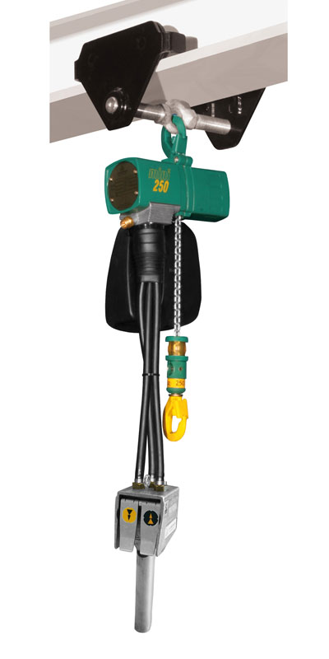
The Mini 250 series hoist from J D Neuhaus shown fitted with overhead trolley, providing a 550lbs lift capacity.
Download high resolution 300dpi image (1200 x 2400 px)
Download low resolution 72dpi image 450 x 900 px)

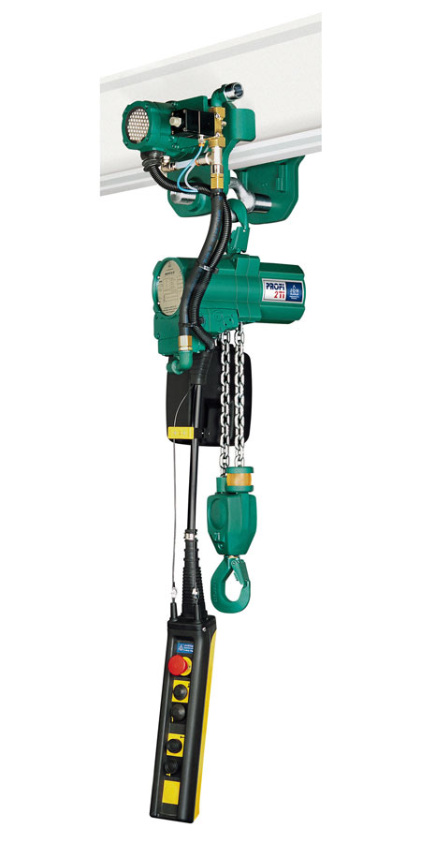
A Profi 2 TI hoist from the J D Neuhaus range featuring a motorized trolley drive, providing a 2 metric ton lift and full pendant control.
Download high resolution 300dpi image (1200 x 2400 px)
Download low resolution 72dpi image 450 x 900 px)
Continued ……
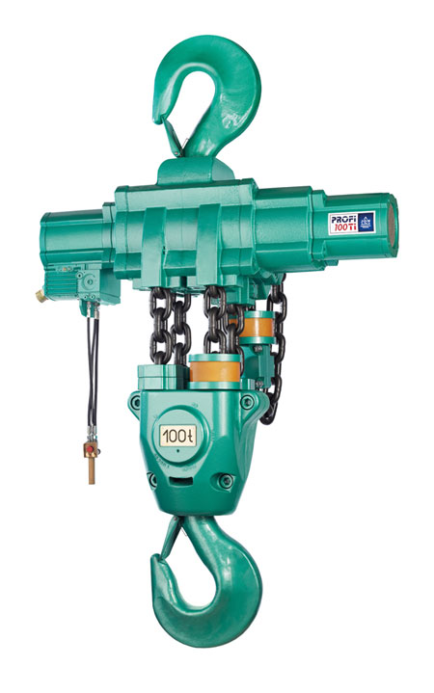
A Profi 100 TI hoist from the J D Neuhaus range, providing a full 100 metric ton lift capacity with 100% duty ratings and unlimited duty cycles.
Download high resolution 300dpi image (1500 x 2400 px)
Download low resolution 72dpi image 563 x 900 px)

Continued ……
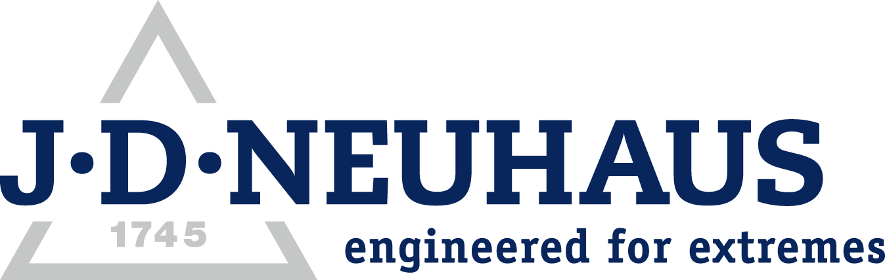
Company information

J D Neuhaus are a privately-owned company, founded in 1745, and for over 270 years they have been using their expertise and experience to manufacture the highest quality hoists and cranes.

Their products offer solutions to almost every material handling problem irrespective of the driving medium: from air and hydraulic hoists up to complete crane installations with explosion proofness.

JDN products are used in a wide variety of industries including:
Airplane Yards; Atomic/Coal Power Stations; Big Bag Handling; Cement Industry; Chemical Industry;
Crane Manufacturers; Dairies; Food Industry; Foundries; Galvanisation; Glass/Ceramics; Large Kitchens;
Leather Plants; Locks; Machine and Plant Construction; Mining; Motor Car Industry; Offshore/Onshore;
Oil Storage; Over/Underground Construction; Paints and Varnish; Painting and Coating Installations;
Paper Industry; Pharmaceutical Industry; Printing Industry; Pyrotechnics Industries; Refineries; Sawmills; Shipbuilding and Shiprepair Yards; Ships; Space Technique; Spray Booths; Steel Works; Surface Technique;
Tank Cleaning Devices; Textile Industry; Tunnel; Tyre Manufacturers; Vacuum Technique

Contact J D Neuhaus

J D Neuhaus are represented in more than 90 countries and over 70 branches Worldwide.

Germany
J D Neuhaus GmbH & Co. KG, 58449, Witten-Heven, Germany
Tel: +49 2302 208-219 Fax: +49 2302 208-286
e-mail: info@jdngroup.com www.jdngroup.com

France
J D Neuhaus S.A.R.L., 24, rue du Président Krüger, 69008, Lyon, France
Tel: +33 4 3790-1745 Fax: +33 4 3790-1746
e-mail: info@jdneuhaus.fr www.jdngroup.com

Great Britain
J D Neuhaus Ltd, Unit 6 Kirkton Avenue, Pitmedden Road Industrial Estate, Dyce, Aberdeen, AB21 0BF, UK
Tel: +44 1224 722751 Fax: +44 1224 729895
e-mail: info@jdneuhaus.co.uk www.jdngroup.com

Singapore
J.D. Neuhaus Pte. Ltd, 21 Toh Guan Road East, #09-02 Toh Guan Centre, 608609, Singapore
Tel: +65 62758911 Fax: +65 62758922
e-mail: info@jdn.com.sg www.jdngroup.com

USA
J.D. Neuhaus L.P., 9 Loveton Circle, MD 21152 Sparks, USA
Tel: +1-410 472-0500 Fax: +1-410 472-2202
e-mail: info@jdneuhaus.com www.jdngroup.com

